Twilight Core

Contents

Functional specification 2

Style of the game 2

Player mechanics 2

Combat 2

Core 3

Focus Mode 3

Ideas 4

Setting 4

Premise 4

INTRO 4

Plot 5

Stages 6

1 - Asura’s Path 6

2 - The Black Forest 6

3 - Riverbank 7

4 - Lotus Garden 7

5 – Temple of the Deva 8

6 - Temple Courtyard 8

Characters 9

Player Character: Soma 9

Boss 0.5 - Asura 10

Boss 1 - Maaya, Forest Guardian 10

Boss 2 – Joanette, the Spider Queen 11

Boss 3 – Danu, Mother of the Asura 12

Boss 4 – Saraswati/Lakshmi/Parvati Tridevi 13

Mechanics 15

Player 15

Score system 15

Controls 15

GFX 16

GFX that need to be replaced with bought/free/self-made assets 16

Music notes 17

Development 18

In development 0.5 18

Goals for 0.5 (2022) 18

DESIGN 18

STAGE/BOSS DESIGN TWEAKS 18

TECHNICAL 19

See if possible / necessary: 19

Terra Feminarum notes ( 30.5.2022) 19

UNITY NOTES 19

0.5 (July 2022) 21

0.4.1 21

0.4.2 21

0.4.3 21

0.4.4 21

0.4.5 22

0.4.6 22

0.4.7 22

# Functional specification

## Style of the game

This game is a danmaku (bullet curtain shoot 'em up) game. Much of the gameplay relies on surviving a curtain of bullets shot by waves of enemies while powering up the character by collecting various points left by shot enemies. Additionally the player's weapons (Day Core & Night Core) can be upgraded to improve basic attributes and the damage done by their special attacks (bombs). Every stage features many enemy waves, often interrupted by a mid-boss with more complex patterns and the stage ends with a boss-battle with many bars of hit points to deplete and many phases of different bullet curtain patterns.

## Player mechanics

### Combat

Player is able to continuously shoot upwards approx. 10 bullets per second

### Core

Core is a weapon that has passive abilities (shooting power and score multiplication) and an active ability (bomb). When the bomb is used or the player is hit the Core bar depletes and the Core powers down.

### Focus Mode

Changes the core in use from Day Core to Night Core and the passive abilities that come with the core (magnetic point collection, slower movement speed for accurate dodging)

# Ideas

## Setting

The setting heavily relies on Hindu/Vedic mythology and Indian cultural motifs. The story is constructed on top of stories from Hindu/Vedic mythology with a creative variation here and there. The narrative is from the main character's perspective as she journeys through the undiscovered realm.

## Premise

Every world has its own Chandra, a guardian of its solar rhythm. Soma is a Chandra of this world, tasked to guard the Day, Night, and Twilight Cores, all responsible for the phases of the day. Soma is also an avid pumpkin farmer and developed the hobby to battle her daily monotony. One day she thought “I wonder if my pumpkins grew a bit fatter if the day lasted just a tiny bit longer” and decided not to activate the Twilight Core that night. To activate a core, she needs to hold it to its pedestal for a moment and the phase of the day changes. After she’s done, she puts the cores into her hat. As the sun was to set, she was measuring her pumpkins on her yard. She feared that reality would break but alas, it didn’t. As she was crawling on the ground her hat fell off and the Twilight Core rolled out. Suddenly an Asura appeared from the woods and snatched the core, and ran off. Soma screamed and grabbed her broom in pursuit, planning to use the Day and Night cores to defeat the Asura.

### INTRO

“Any world that rotates, gets their own guardian, a Chandra.”

“The solar rhythm of this world has been trusted to a young Chandra named Soma.”

“To battle the daily monotony of maintaining the Cores she picked up a hobby: growing pumpkins, overly obsessing over their size and quality.”

“One day she thought it was a good idea to see if they grow a little larger if only the day lasted a little longer…”

“The cores of Day and Night in her hat stayed intact when she crawled in the patch and dropped her hat.”

“But the Twilight Core was stolen by quick hands…”

## Plot

The Lordess of the realm of Asuras has opened pathways to the regular world and sent Asuras to fetch her a mystical item, “The Twilight Core”. But by removing it, the world stopped seeing sunrises or sunsets, only perpetual night or day.

You are Soma, a happy-go-lucky witch, a pumpkin farm owner who loses her Twilight Core to a thieving asura.

Soma tracks the Asura who stole the core and follows its path to a forest that is guarded by Maaya, a Friendly Huldra.

After defeating her, Soma travels deep into The Black Forest where Joanette, the Queen of Spiders is helping the Asuras open pathways between worlds. Soma defeats her and follows the Asura through the pathway.

In the Asura realm Soma is flung to a river from the portal. After shaking herself dry she follows the riverbank and catches up to the asura who tries to use the core against her again. She chases it away and meets Danu, the mother of Asuras who is grieving her lost son Vritra.

Soma enters a lotus garden of the (Boss6) temple where she meets the Trio of Devi that guard the temple.

Stage 5 signifies the various layers of the temple (Asura, Human, Deva, Brahma). Soma makes her way to the middle and meets (Brahma) who’s given (Boss6) a boon that makes her immortal. (Brahma) doesn’t think Soma is suitable to mess with deity business so she has to defeat her.

After proving (Brahma) wrong she teleports Soma to an astral plane, a courtyard beyond the temple. Soma lures out (Boss6). After Soma survives her initial attacks, an avatar appears and knocks the core out of (Boss6)’s hand, and Soma catches it. (Boss6) is now vulnerable and using the Twilight Core Soma is able to defeat her.

Afterwards Soma returns to her realm to enjoy the sunsets and sunrises again.

## Stages

1 - Asura’s Path

*BGM - “Asura who remain Asura”*

Soma follows an asura that has stolen the Twilight Core. After pursuing him for a while, dodging all the gandharvas that are adamant to stop her advance, she encounters the boss of the gandharvas who has been asked by the spider queen to let no one enter the forest while her rites are on.

* Boss 0.5: Asura
* Boss 1: Maaya, Forest Guardian (Fox Gandharva)

#### Environment

Fields, pumpkins and a fenced road with trees on the side. Sunny day

#### Enemies

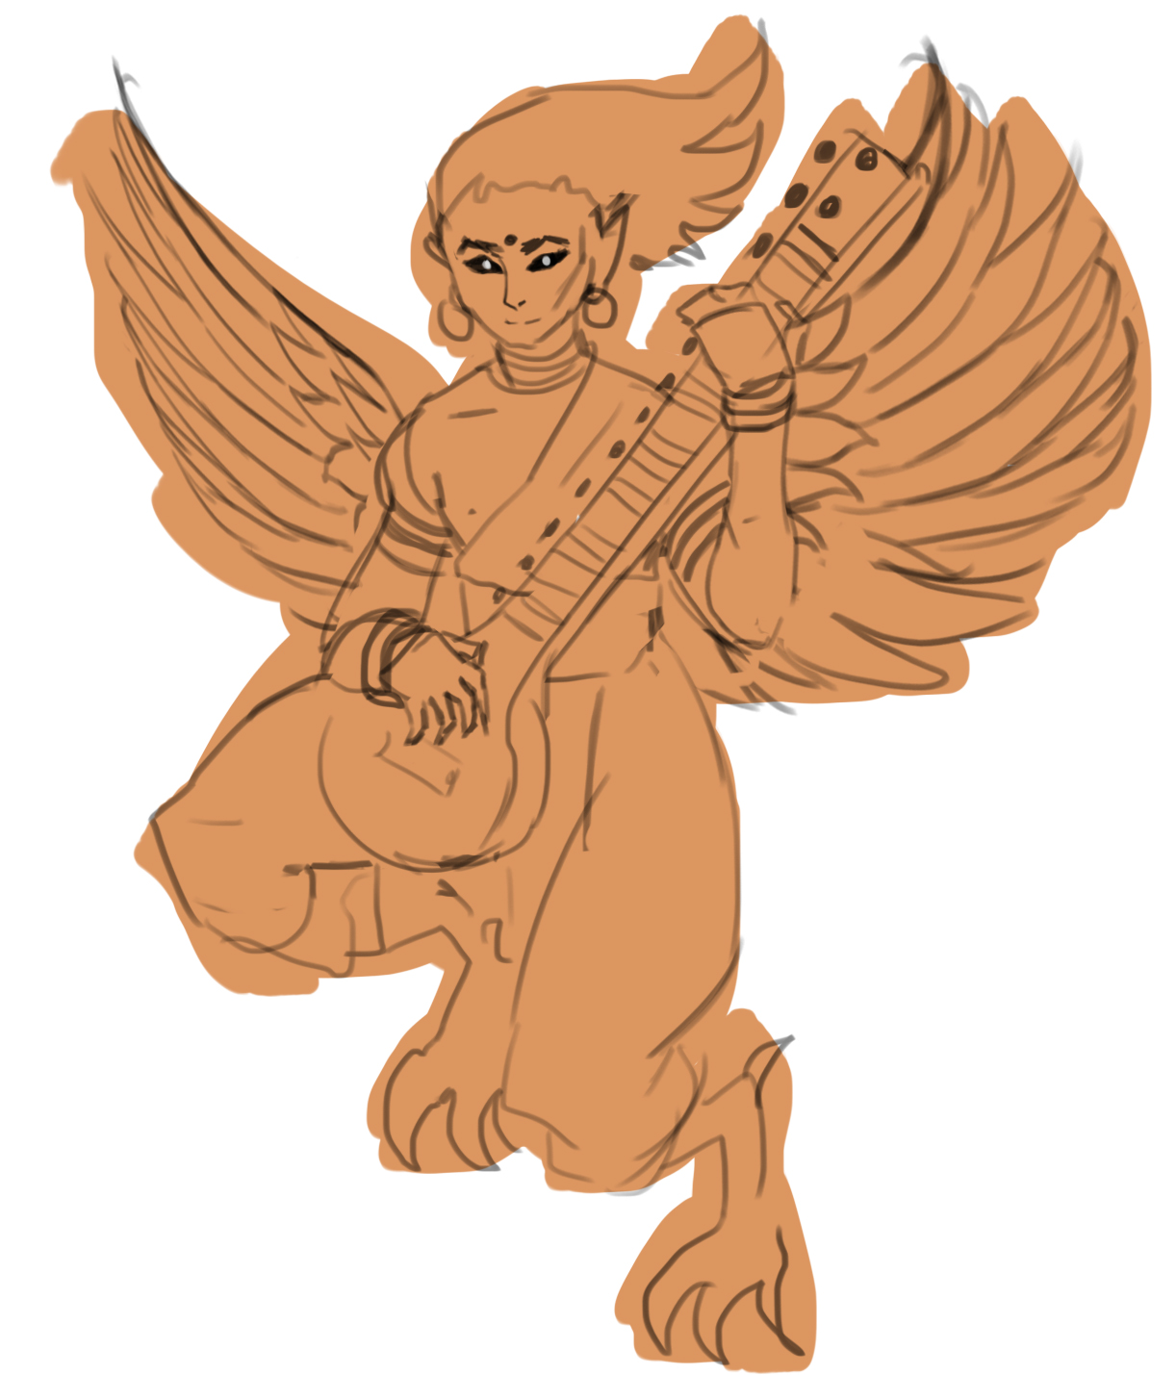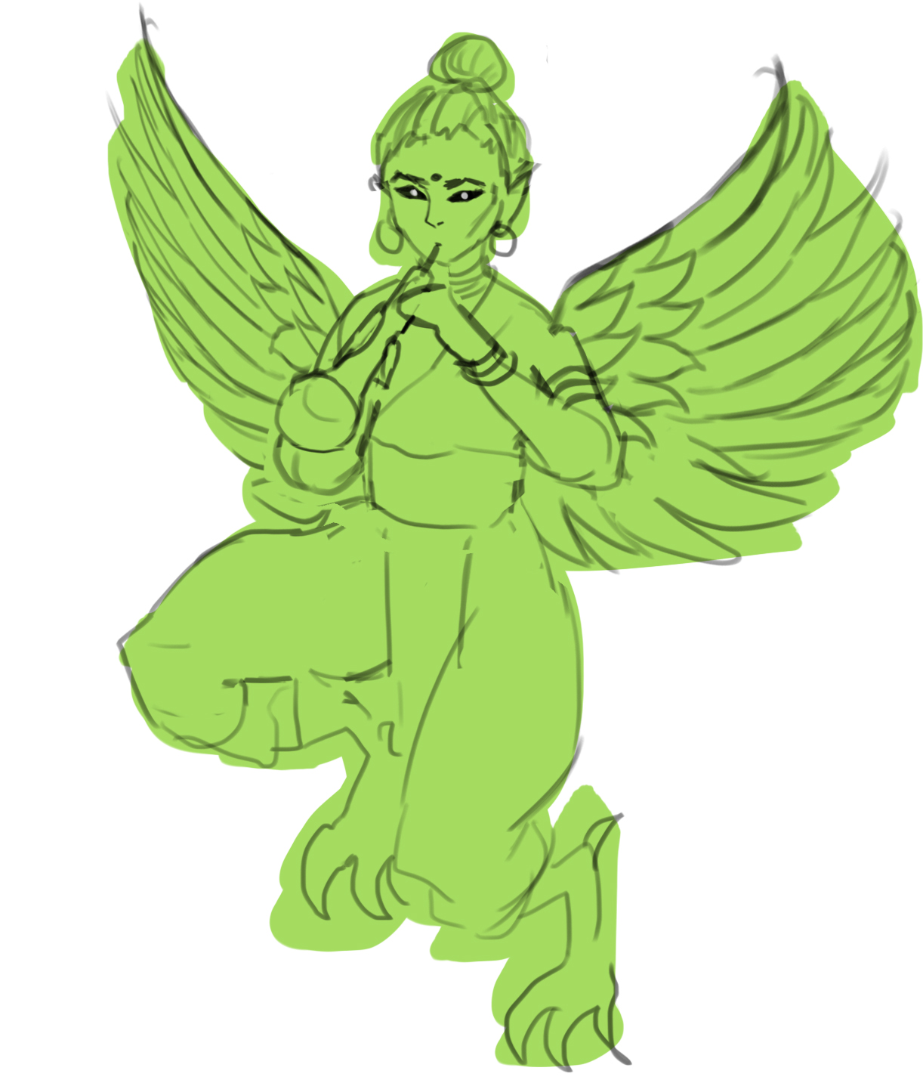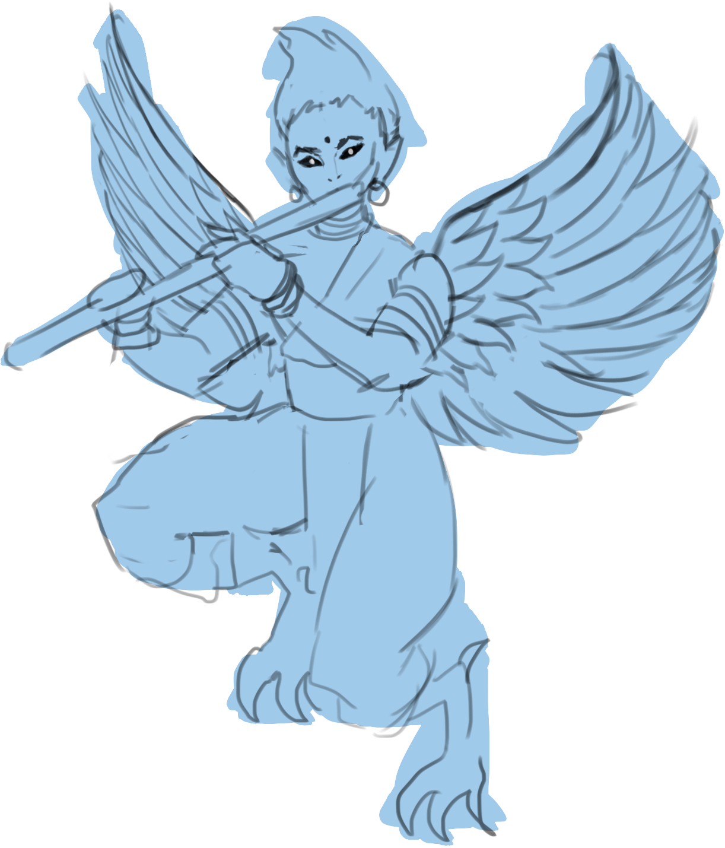

Forest Guardian’s minions, various Gandharvas. **Reoccurring enemies throughout the game.**

*Some are part animal, usually a bird or horse and are connected with trees and flowers. They have superb musical skills, guarded the Soma and made beautiful music for the gods in their palaces. Gandharvas are frequently depicted as singers in the court of Gods and act as messengers between the gods and humans.*

**Art:** Wings, animal feet, different instruments (sitar, flute, shehnai). Different colored garments by instrument. Sprite has flapping wings

**Bullet ideas:** Leaves, flowers, musical notes

2 - The Black Forest

*BGM - “Spelunker”*

Soma proceeds to the forest when she notices a twilight leak. She follows it deeper to the forest where she meets a Spider Queen who is opening portals to the asura’s realm. She defeats her and travels through a portal.

#### Environment

Thick woods, red lights between. Dark lighting

#### Enemies

Some gandharvas, Spider Queen’s squires

* Midboss: ??
* Boss: Joanette, Spider queen
  + BGM: Void Dance

3 - Riverbank*BGM - “”*

Asuras all around

* Midboss: Lakshmi
* Boss: Danu, Mother of Asura

4 - Lotus Garden

A stage-long bossfight against the three Devi, Saraswati, Lakshmi and Parvati

*There Champac and As'oka flowers*

*Hung glorious o'er the summer bowers,*

*And mid the waving verdure rose*

*Gold, silver, ivory porticoes.*

*Through all the months in ceaseless store*

*The trees both fruit and blossom bore.*

*With many a lake the grounds were graced;*

*Seats gold and silver, here were placed;*

*Here every viand wooed the taste,*

*It was a garden meet to vie*

*E'en with the home of Gods on high.*

4th stage and boss? Asura

* Boss: The Tridevi

5 – Temple of the DevaMain character meets (Brahma) who’s given the final boss a boon that makes her immortal. (Brahma) doesn’t think the main character is suitable to mess with deity business so she has to defeat her. After defeating (Brahma) main character acquires a power from her to temporarily change day or night to twilight to kill the final boss. (Twilight Core)

* Boss: (Brahma)

### 6 - Temple Courtyard

## Characters

### Player Character: Soma



Every world has a guardian of its solar rhythm. Soma is tasked to guard the Day, Night, and Twilight Cores of this world, all responsible for the phases of the day. Soma is also an avid pumpkin farmer and developed the hobby to battle her daily monotony. The story starts when she loses the Twilight Core to a thief and is desperate to get it back to restore the balance of the world.

### Boss 0.5 - Asura

* Special: Twilight Core: Depulsio
* *"Asuras who remain Asura" share the character of powerful beings obsessed with their craving for ill-gotten Soma, and for wealth, ego, anger, unprincipled nature, force, and violence. Further, in Hindu mythology, when they lose, miss, or don't get what they want (because they were distracted by their cravings) the "Asuras who remain Asuras" question, challenge, and attack the "Asuras who became Devas" to loot or extract a portion of what the Devas have and the Asuras do not.*

### Boss 1 - Maaya, Forest Guardian



* BGM: “Sweet Trickster”
* *Māyā connotes a "magic show, an illusion where things appear to be present but are not what they seem"*
  + She pretends to be a human but is a fox. But her tail gives her away. Huldras are usually said to be very self-conscious about their tail and back, and attacks anyone who points them out.
* Boss of the gandharvas of the area
* Spear
* Spell idea: spiral spears
* hard to catch, teleportation
* fox fires: slow cluster bullets

### Boss 2 – Joanette, the Spider Queen



"In the Vedic philosophy of India, the spider is depicted as hiding the ultimate reality with the veils of illusion.”

“Indra's net is used as a metaphor for the Buddhist concept of interpenetration, which holds that all phenomena are intimately connected. Indra's net has a multifaceted jewel at each vertex, and each jewel is reflected in all of the other jewels”

“In some schools of Buddhism and in Hinduism, the image of Indra's net is a metaphor for the emptiness of all things, and at the same time a metaphor for the understanding of the universe as a web of connections and interdependence”

“If a person comes into contact with a Live spider by default, he or she will get new clothes as per local belief in Hindu customs.”

Spider Queen is opening portals to the asura world, symbolizing Indra’s Net and its connectivity.

* Basic phase 1: small web clusters, homing arrows, spiders
* Basic phase 2: shoot laser webs, slow spider bullets
* Spell 1: Indra’s Net
  + Maelstrom spiral + Giant spiderweb with big rotating bullets spawned in a circle
* Final spell: Void Dance
  + Starts opening a white void behind her (serving as the portal the player goes through to the next level)
  + Otherworldly bullets come out of the void while boss shoots homing bullets the player has to dodge rhythmically

### Boss 3 – Danu, Mother of the Asura

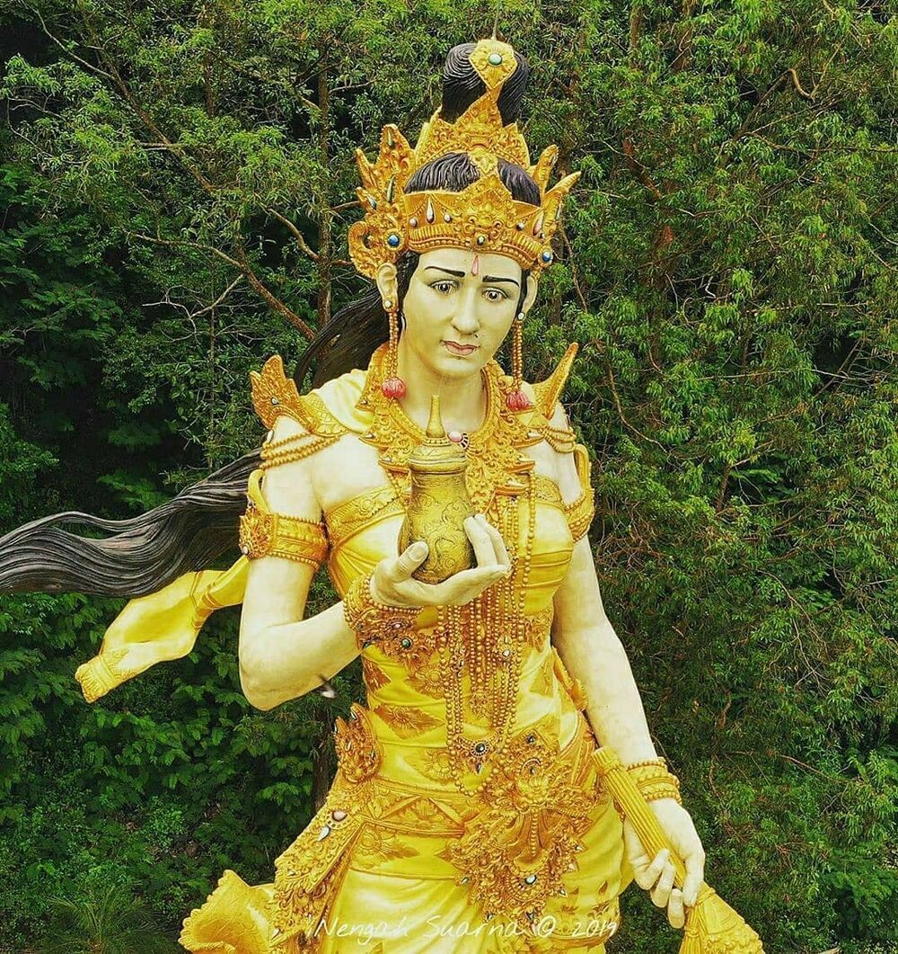

* *BGM: ”Mother’s Fears, Mother’s Tears”*
* दानुः As a word for "rain" or "liquid", dānu is compared to Avestan dānu, "river"
* The mother of the thieving Asura
* Mourns her son Vrtra, slain by Indra. Wants to stop Soma from pursuing her children
* Water patterns: Rain, tears, riverwater

**Ideas:**

* Top layers clouds turn into stormy clouds, rain
* Falling rain bullets + pouring water from big can
* Accelerating Tear clusters
* A river flow (negative space?)
* Asura bodyguards (killable, which intensifies the pattern?)
* Water Bullets accumulate on the bottom of the screen
  + Probs needs bullets to be changed into rb2d
* Summon Rewa from the Narmada River
* [SPELL] ”Mother’s Fear: Loss” Total darkness uncounting the immediate area around the player
* [SPELL] ”Mother’s Fear: Death”

### Boss 4 – Saraswati/Lakshmi/Parvati Tridevi

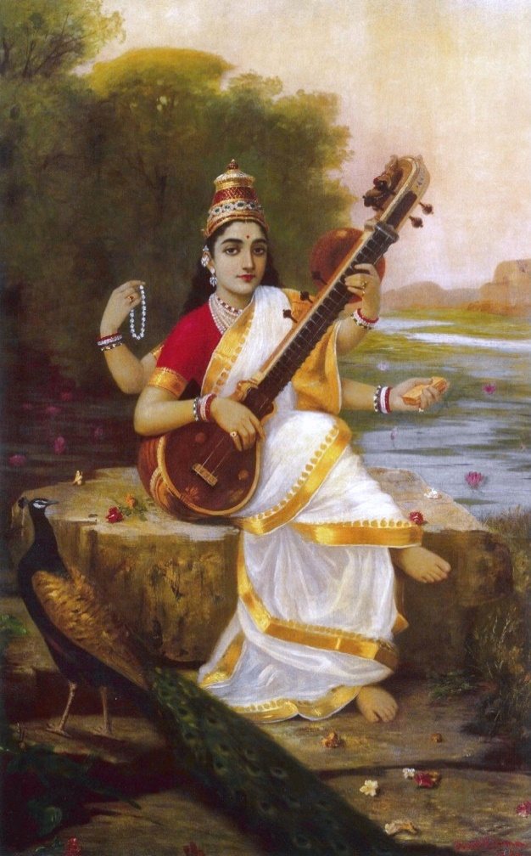 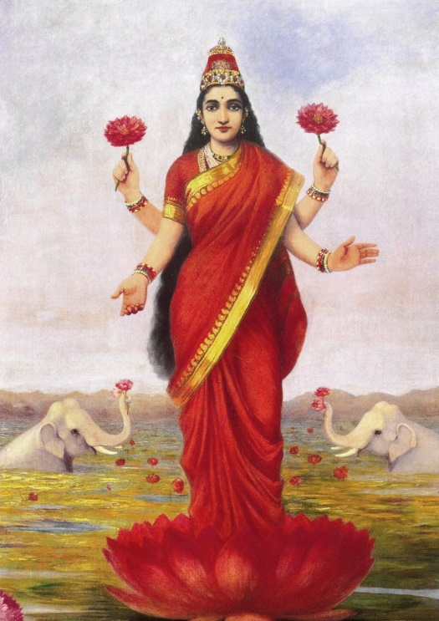 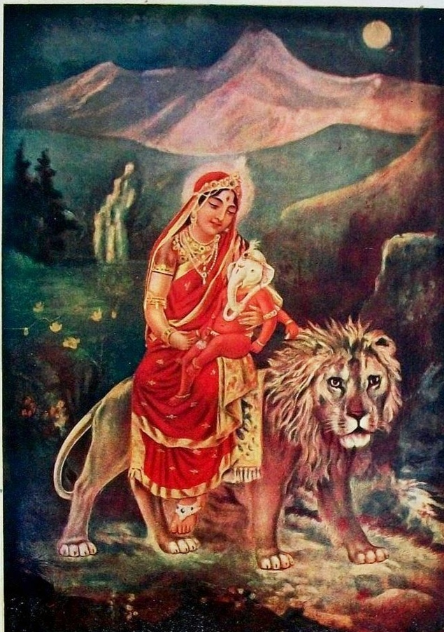

* *BGM: ”The Three Faces of Self-Reflection”*
* 4-phased boss with each phase representing one facet of the Tridevi and the last one their ultimate form, Lalita
* *Tridevi goddesses are given the eminent roles of Creator (Mahasaraswati), Preserver (Mahalakshmi), and Destroyer (Mahakali)*
* PHASE 1: Saraswati सरस् (knowledge that purifies) is the goddess of learning, arts, and cultural fulfillment. A beautiful woman dressed in pure white, often seated on a white lotus, which symbolizes light, knowledge and truth. Holds a pustaka (book or script), a mālā (rosary, garland)
  + **Pattern ideas: “A Stroke of Genius” MUSICAL NOTES, LETTERS, PAINT STROKES**
  + [SPELL] “Avatar: Vidya” विद्या the formless concept of wisdom and knowledge in all of its aspects. Cosmic intelligence, cosmic consciousness, and cosmic knowledge.
* PHASE 2: Lakshmi लक्ष्मी is the goddess of wealth, fertility, auspiciousness, light, and material and spiritual fulfillment, prosperity, glory, magnificence, joy, exaltation, and greatness, and spiritual fulfillment. An elegantly dressed, prosperity-showering golden-coloured woman standing or sitting in the padmasana position upon a lotus throne, while holding a lotus in her hand, symbolising fortune, self-knowledge, and spiritual liberation
  + Lakshmi is very often shown with one or two elephants, and occasionally with an owl. Elephants symbolize work, activity, and strength. The owl signifies the patient striving to observe, see, and discover knowledge, particularly when surrounded by darkness. As a bird reputedly blinded by daylight, the owl also serves as a symbolic reminder to refrain from blindness and greed after knowledge and wealth have been acquired
  + **Pattern ideas: “A Dream of Avarice” (“RICHES”), FLOWER PETALS, COINS, GEMS, THROW IT ALL IN**
  + [SPELL] “Avatar: Gayatri” गायत्री is the personified form of the Gayatri Mantra, a popular hymn from Vedic texts.
* PHASE 3: Parvati पार्वती is the Hindu goddess of power, nourishment, harmony, devotion, and motherhood. She is a physical representation of Devi in her complete form  
    
  Parvati, the gentle aspect of Devi Shakti, is usually represented as fair, beautiful, and benevolent. She typically wears a red dress (often a sari), and may have a head-band  
    
  Hands may hold a trident, mirror, rosary, bell, dish, goad, sugarcane stalk, or flowers (such as a lotus)  
    
  The Puranas tell the tale of Sati's marriage to Shiva against her father Daksha's wishes. Daksha does not invite Shiva to his yagna. Sati comes on her own and immolates herself at the ceremony. This shocks Shiva, who isolates himself in the mountains. Sati is then reborn as Parvati, "she from the mountains"
  + **Pattern ideas: “A Gift of Benevolence”, food related? Trident? Flowers?,**
  + [SPELL] “Avatar: Mahakali” महाकाली is the Hindu Goddess of destruction and doomsday. Mahakali is fiercest of the Goddesses of universal power, time, life, death and both rebirth and liberation. She devours Kala (Time) and then resumes her own dark formlessness. She is also the consort of Mahakala, the god of consciousness, the basis of reality and existence. Mahakali in Sanskrit is etymologically the feminized variant of Mahakala or Great Time (which is interpreted also as Death), an epithet of the god Narasimha or Shiva in Hinduism.
  + According to Lalitopakhyana of Brahmanda Mahapurana, Parvati, Lakshmi, and Saraswati are the three incarnations of Lalita
* Phase + spell per devi +Final form Lalita?

# Mechanics

## Player

* Day / night core meter
* Day Core: Starlight special
  + Star bombs explode in different places, destroying enemies and bullets
* Night Core: Trick or treat
  + Pumpkin shaped field consumes all bullets around player
* Add life gen points? or just extra lives
* Both cores deplete if special used when hit
* Cores can be leveled with exp points
  + Boosts up the special OR makes passives better
  + Night Core boost: spawns additional rotating pumpkins to magic circle

## Score system

* Certain score threshold yields an extra life?
* Scorepoint multiplier from core levels?

## Controls

* [Arrow keys/WASD ] – Move
* [Z] – OK/Shoot
* [X] – Special attack
* [Shift] – Focus/Night mode
* [ESC] – Pause Menu / Back out of menu

# GFX

## GFX that need to be replaced with bought/free/self-made assets

* Stage1/2 ground bg
* Boss0.5 bg
* Boss1 bg
* Boss magic circle
* Player special circle + pumpkin

## 

# Music notes

* Boss1 tempo up
* Stage1 kick too loud
* Stage2 kick too loud, low synth too loud 0:35 (let high synth take over)
* twilight core make bassline

# Development

## In development 0.5

### Goals for 0.5 (2022)

* Stage 3
* Boss 3
* Stage/boss 4

FIXED BUT UNCONFIRMED

BUG BUT UNCONFIRMED

URGENT, IS BROKEN

PRIO FOR GOAL

SUGGESTED

MINOR

### DESIGN

* invulnerability indicator for stage2 asuras (shield around sprite?)
* keyboard key sprite for prompts
* look up free SFX from asset store
* Put toasts in a que so they can all be played???

### STAGE/BOSS DESIGN TWEAKS

* spawn enemies if stage3 boss 2.5 dies too fast
* set boss health by phase for better control
* Make stage1 WAY easier
* boss1phase4 more time
* tridevi less health
* boss4 phase1 impossible to dodge on nightmare
* boss2 more health
* boss3 more health

### TECHNICAL

* Life sprite size fucks up on test build (because of different reso?)
* Remember to reset boss4phase1 rotation after axisrotations

### See if possible / necessary:

* Homing bullets as endstage bonus / selectable from menu touhou style?
* idea: pattern seems impossible at first but some clearly marked bullets disappear
* idea: arrow worm
* bullets scale up the farther they are from boss (to create 3d tunnel effect)
* heroku database for global hiscores
* music box menu for game music(DON’T EVEN THINK ABOUT IT YET)
* twilight points -> temp invulner when hit, “Bomb escape system”
  + for final level when player gets the twilight core + OP powers anyway

### Terra Feminarum notes ( 30.5.2022)

~~At least partly implemented~~

* ~~Think of more interesting bullet shapes relating to the enemy/environment~~ 
  + ~~More bullet cluster designs~~
  + ~~Negative space bullets (forced path) (this almost exists as the broken pacman pattern)~~
  + 3D bullet patterns
* ~~Player max power fill screen with bullets~~
* ~~More range for player bullets allows lots more simultaneous waves~~
* ~~More different patterns into a single phase /spell + sfx for small events~~
* ~~Get power points during boss fight~~
* More elaborate enemy movement patterns and longer paths (waving, loops + such)
* ~~Other bullet sources than shooter (specifically in boss fights)~~
* ~~Boss patterns have timeout if taking too long~~

**(6.6.2022)**

* ~~Visual counter for lives (hearts etc.)~~
* ~~Different bomb based on core level~~

### UNITY NOTES

* Unity limits fps by default
* If enemyspawner breaks, make sure stagetimer zeroes before stage begins
* Biggest causes for lag so far: Physics2D collision, FixedUpdate and Update (avoid calling getcomponent<>() too often), TMPro generating
* Don’t add vars to BulletMovement, leads to bad refs. Deal with all vars in BMP
* Avoid calling new too often, especially in coroutines with waitfors
* FixedUpdate is called many times before update, therefore creating a lot more garbage than anticipated (lag when 100s of bullets on screen). Use FixedUpdate only for physics
* Avoid from finding gameobjects on game start, fucks with build
* Avoid calling gamecontrol on awakes/starts, doesn’t work that well on build

## 0.5 (July 2022)

### 0.4.1

* Player retains core power to the next stage
* Boss music loops from a certain point instead of the beginning
* Boss4 bgm sketch
* TrailMaker changed to using the ParticleSystem
* Boss Hitfx changed to using the ParticleSystem
* EnemyMovement correct rotation func after axisrotation

### 0.4.2

* Death FX
* Stage3 bgm sketch
* New pattern Shape (P_Circle obsolete)
* New movement type Unfold
* New movement type Move while rotating around pattern axis, retain shape or not
* Stage 3 designing
* Boss 2.5 Lakshmi
* Fireball bulletsprite all colors
* New bulletsprite Jewel all colors
* New bulletsprite coin
* New bulletsprite pearl
* Start boss3 design

### 0.4.3

* Restored “pacman” pattern
* Func for setting a glow of separate color
* Func for modifying all spawned bullets in the pattern whilst executing
* Tear bullet
* Boss 3 fight done
* Balance testing: Taking hit doesn’t destroy all pickups, instead destroys all enemies
* Moved all input into InputHandler
* Back button for tutorial and .1 sec wait when exit

### 0.4.4

* Bugfixes
* Enemy health can be set
* Started designing stage4, boss4
* Several tweaks to stagehandling
  + hold stage timer until started in stage script
  + play music from stagescript
  + set boss health to percentage
  + exclude boss 4 from normal handling

### 0.4.5

* Scrapped BulletBouncer class
* Fixed bossmusic not looping from point
* Simplified inputcheck
* Put bosstimersfx in its own source so it doesn’t get interrupted
* Rolling dialog text + SFX
* Prepared stage5 assets
* New toast font
* Changed gameover/complete images to tmpro with new fonts
* Tweak rightsidepanel layout
* Fadeout boss music after complete
* Update speaker info/pic correctly

### 0.4.6

* Added “hard” difficulty mode
* Fixed dialog chars not showing up/fading out as they should
* Ingame-check for gamecontrol for determining if in mainmenu scene or level scene
* Bulletmovement checks distance to player special instead of activating the collider for less lag
* New Lotus bullet
* A way to store/load custom pattern data
* Fixed lives/xp not resetting on restart
* Fixed mainmenu waiting for loadcheck
* Boss4 phases 1,2

### 0.4.7

* Shape patterns now load from resources
* Fixed pickup points spawning outside play area
* Fixed stage start fade and simplified stage init
* Laser hitbox disables earlier
* Raised enemybullet sprites order in layer
* Removed lasers from boss3phase1
* Added more transparency for biggest player projectiles so bullets easier to see
* New stagetoast + stage subtitle
* Small death particle effect for enemies
* New player special toast, fixed pos not resetting when another special used while toast is up
* Differentiated boss survival bonus and boss time bonus
* New dialog box / name plate
* Fixed lifesprites not scaling with reso
* Set max lives to 9